Addition Strategies
- Add one number in parts (only one of the numbers is decomposed)
48 + 25
48+2=50
50+20=70
70+3=73
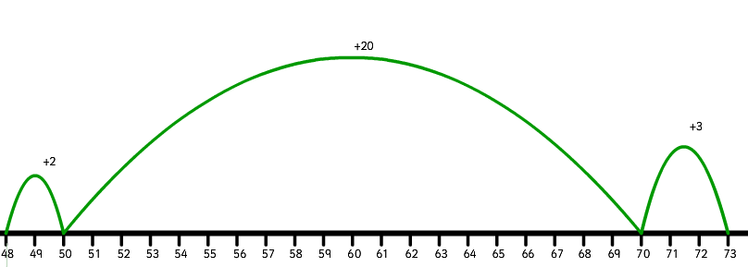

- Add by place (both numbers are decomposed)
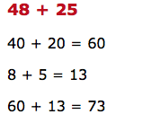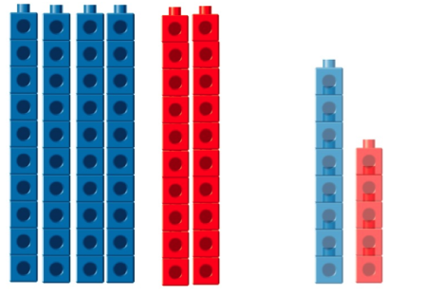

- Changing the numbers and compensating
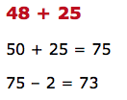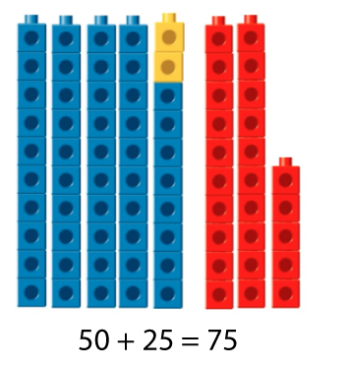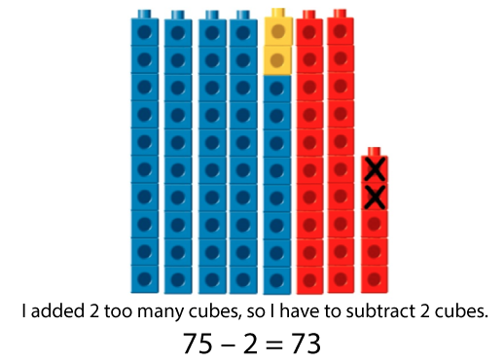

Creating an Equivalent Problem
48 + 25
48+25=50+23 (48+2=50 and 25-2=23)
50+23=73

Context: There were 48 kids in one room and 25 in the other, 2 moved from the room with 48 to the room with 25. The total number of students is still the same.

Subtraction Stategies
- Subtract in parts (only one of the numbers is decomposed)
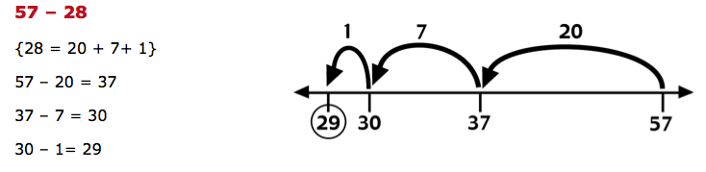
- Adding up
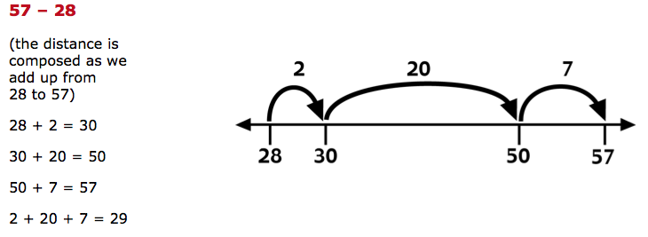
- Subtracting by place (both numbers are decomposed)
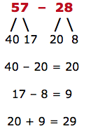
- Changing the numbers and compensating
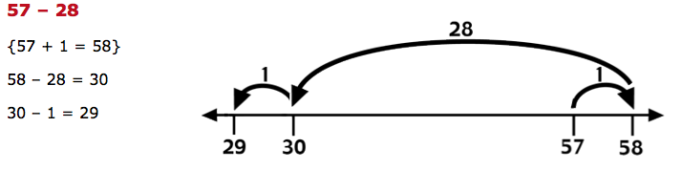
- Creating an Equivalent Problem
